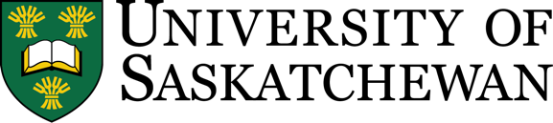

Sustainable Development Goals (SDGs) in Teaching & Learning Workbook

Learning/Guiding Questions

- Which Sustainable Development Goals SDG(s) does your course address?
- Could you identify one or two specific goals and targets (indicators) your course helps work towards?
- How might you convey this to your students?
- What kind of alignment would they see?
- How would it help their learning?

This course is designed to help you:

- Identify the SDGs that are most pertinent to your course.
- Develop learning outcomes that will help students work towards the goal(s).
- Adapt methods of instruction for student engagement in sustainable development.

In future teaching & learning, how might we:
- Modify curricula to bring in relevant SDGs?
- Add new courses to expand students’ knowledge, skills, attitudes related to the SDGs?
- Use interactive pedagogies such as enabling interaction with society?

This document and course is licensed under a Creative Commons Attribution-NonCommercial 4.0 International License by Aditi Garg for the Gwenna Moss Centre for Teaching and Learning at the University of Saskatchewan.

Table of Contents
Sustainable Development Goals (SDGs) Short Course Workbook 1
Overview of the goals 3
Pick a P 4
Explore the SDGs 4
Rank and Sort the SDGs for USask (three groups) 4
Sustainable Development Goals – Personal Reflection 4
Plan for Action: How we’re going to get there. 6
Taking Inventory 6
My Course, My Goals 7
Learning Outcomes and the SDGs 8
Need to know and nice to know 9
Biosphere/Society/Economy and Graduate Attributes 10
What will students do? 11
Links for learning 12
General information 12
Tools/Lessons/Examples 12
Reading 12

Overview of the goals

The SDGs address complex and interlinked social and environmental challenges. These are Global Goals at the broadest level. This isn’t new. The United Nations has been trying to think of common language for nearly 50 years.

As Sylvia Earle, noted oceanographer states, “no blue, no green” no ocean, no land. No land, no society, or...economy. In higher education, different contributors address issues in all three layers of this ‘wedding cake’ model. The other uniting force that can’t go unaddressed is the global pandemic. This will restructure how we envision wellbeing and health and its place in this model.
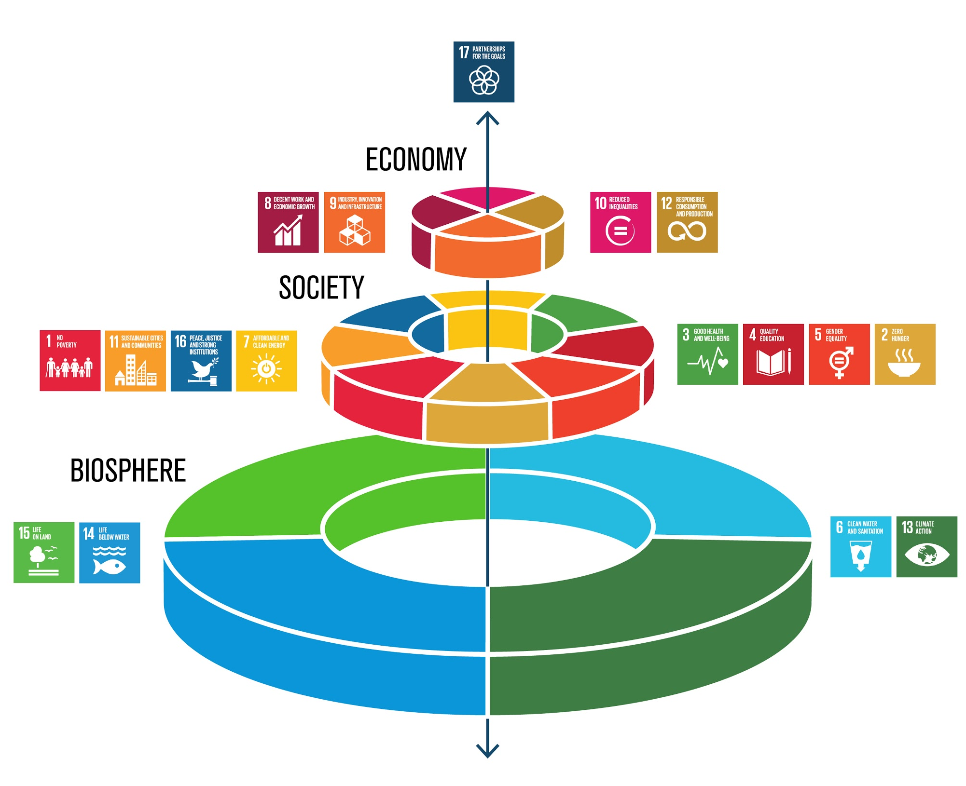
Figure 1 https://www.stockholmresilience.org/research/research-news/2016-06-14-how-food-connects-all-the-sdgs.html
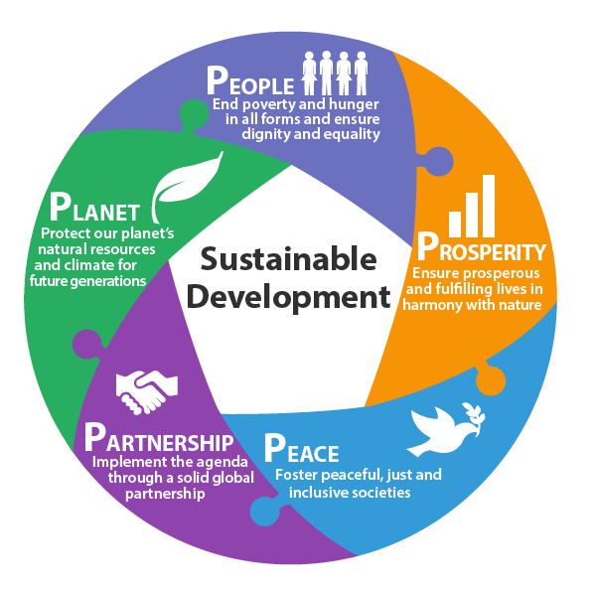
These 17 goals also fit within the 5P Framework of People, Planet, Partnership, Peace, Prosperity.

Pick a P

Which “P” does your work/life fall under?

Goals means we are trying to move from one position to another more favourable position. This requires change.

Some questions (from the Climate Reality Project)

1. Must we change?
2. Can we change?
3. Will we change?

https://www.climaterealityproject.org/)
Figure 2 https://sdg.gdrc.org/post/128479353317/the-five-key-elements-5-ps-that-led-to-the

Explore the SDGs
https://sdgs.un.org/goals
Hover over each goal, click for More Info, if you want
What is the difference between goal/target/indicator?

Pick YOUR top 4 Goals

One way you currently work towards each goal in personal/research/teaching/community and the greatest unknown in working towards this goal.
Indicate if this is based in social (S), ecological (L), economic (N), or worldviews (W) concerns.

# | SLNW | Personal | Research | Teaching | Regional | Greatest uncertainty

Plan for Action: How we’re going to get there.
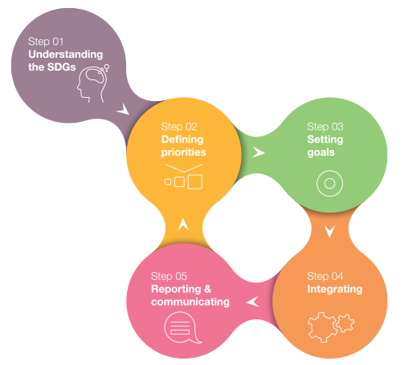
Figure 3 https://sdgcompass.org/

Taking Inventory
In my course, which goals are relevant or not?

Of the goals I do want to work towards (solutions), for which ones do I currently have net-positive impact?

https://sdgimpactassessmenttool.org/instructions
Top right corner – log in (sign up)

My Course, My Goals
Reflect on your course. What are your top goals?
Which SDG(s) does your course address?
Are there specific indicators you teach to? https://unstats.un.org/sdgs/indicators/database/

Question | Answer
Could you identify one or two specific goals and targets (indicators) your course helps us work towards?
How might you convey this to your students?
What kind of alignment would they see?
How would it help their learning?
Are there specific targets students will work towards?

Learning Outcomes and the SDGs
MCIC Guide https://www.mcic.ca/uploads/public/files/SF-Full-FINAL-WEB-ISBN-2019.pdf

Steps:
- Open your syllabus in an editable format.
- Code/annotate next to each learning outcome/objective to which SDG it most closely maps a ‘net positive’
- Reflect if this matches what you decided at the end of Module 1
- Pick your top SDG
- Turn to that page in the MCIC guide
- Read the learning objectives associated with that SDG
- Read your learning objectives – how might you rewrite yours to more closely match the intention of the SDG?
- What are the secondary goals (tangential connections or overlaps)?

Example

Original learning outcome: Support a position or decision relevant to self, family, or community by analyzing statistical data, as well as considering other factors. (Math Foundations, grade 11, Saskatchewan)

SDG Outcome: Learners will be able to communicate issues of health, including sexual and reproductive health, and preventative strategies. (Goal 3 Health and Well-being, MCIC)

SDG + Math Outcome: Learners will be able to support a position regarding health to community by analysing and communicating statistical data.

Need to know and nice to know
What do students need to know longterm, be able to know and do now (by the end of the course), and only be familiar with or have an awareness of moving forward?
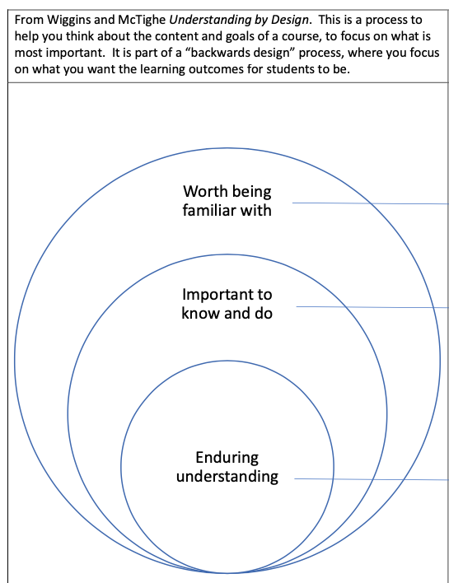
Figure 4 From 2020 Virtual Conference on Global Learning, AAC&U | Skill-Building Workshop - Connecting the SDGs and Global Learning. Dr. Taimi Olsen (TaimiO@Clemson.edu)

Biosphere/Society/Economy and Graduate Attributes

Working with those from similar disciplines, in which quadrant are your graduates currently? Where do you want them to be?
** they can be like a puddle that splashes a bit into all quadrants, at GMCTL we call this the blob.

How might your course embody the idea of ‘town and gown’ – community engagement in learning? (Question inspired by The Hon. Judge David Arnot at People Around the World 2021)

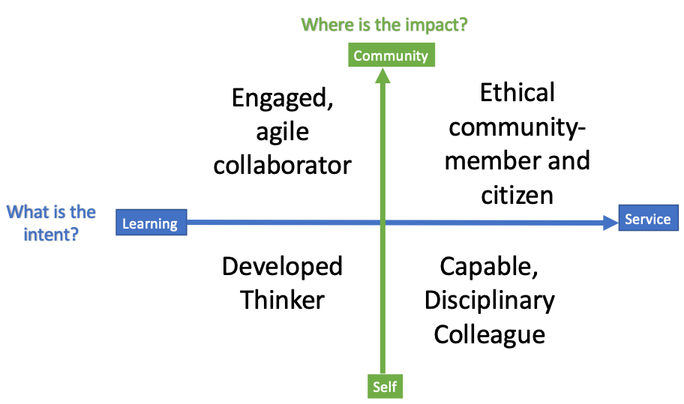
Figure 5 GMCTL Internal Planning Tool, Graduate Attributes derived from https://teaching.usask.ca/about/policies/learning-charter.php#OurLearningJourney

What will students do?
What kind of rich task will students do to work towards your chosen SDG? Review the Instructional Approaches section of The Idea Book https://openpress.usask.ca/ideabook/part/instructional-approaches/ and this USask post https://teaching.usask.ca/articles/case-based-learning.php

This curriculum guide has tables for each goal that outlines examples in tertiary (post-secondary) education https://www.thecommonwealth-educationhub.net/wp-content/uploads/2018/04/CFSDG_UPDF-003.pdf

Using Bloom’s Taxonomy, reflect on how you might design tasks that allows students to work in a higher cognitive order (apply-create). Which materials/content and what kind of interactions will you plan for?
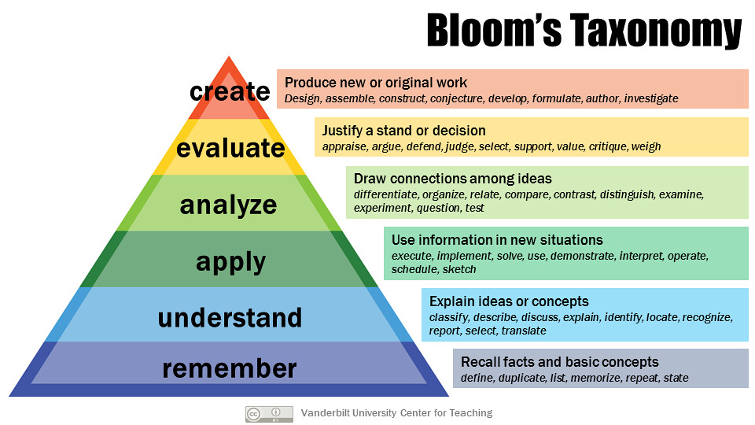

Learning Outcome
Task - short description

 | Knowledge/Understanding | Skills/Application | Attitudes/Values
Verb from Bloom’s
Materials Needed
Activity/Task
How it will be evaluated

Walk through the Assignment Guide to reflect on your assignment structure with https://drive.google.com/file/d/15Z4U_cKHy-4ilgiEJnnopGh8I-HHyFQ4/view?usp=sharing

Other Links for Learning

General information
Decade of Action https://www.un.org/sustainabledevelopment/decade-of-action/
USask International Blueprint for Action 2025 https://plan.usask.ca/international/
SDG Guide (A brief history and moving forward) https://sdg.guide/chapter-1-getting-to-know-the-sustainable-development-goals-e05b9d17801
Use the logos/graphics https://www.un.org/sustainabledevelopment/news/communications-material/
SDG Resources PAW 2021 https://internationaloffice.usask.ca/people-around-the-world-paw-2021.php#SDGResources

Tools/Lessons/Examples
The SDG Academy creates and curates graduate-level courses on sustainable development for learners around the world. https://www.edx.org/school/sdgacademyx

SDG Toolkit for Canadian Colleges and Institutes (section 2 has examples of SDGs embedded in learning and teaching)
https://sdgcicanguide.pressbooks.com/

Cases related to learning & teaching activities integrated in undergraduate, graduate or research degree programs, such as lecture material, assignments, class activities and projects, study trips, etc. https://blogs.upm.es/education4sdg/prueba-elementor/curricular-lt-actions/

The Saskatchewan Council for International Cooperation (SCIC) is a coalition of organizations and individuals working to advance sustainable global development. https://www.saskcic.org/

Lesson Plans (Age 16+) https://worldslargestlesson.globalgoals.org/resources/?_sft_age_group=16&_sft_language=english

Reading
Accelerating Education for the SDGs in
Universities: A guide for universities, colleges, and tertiary and higher education institutions. https://irp-cdn.multiscreensite.com/be6d1d56/files/uploaded/accelerating-education-for-the-sdgs-in-unis-web.pdf

Education for Sustainable Development (ESD) and Global Citizenship Education (GCE)
https://unesdoc.unesco.org/ark:/48223/pf0000372327?posInSet=1&queryId=c22af3a8-df4c-4253-a0d0-ca1a8fe2fdc7
Mapping/Scoring SDGs https://dashboards.sdgindex.org/map

