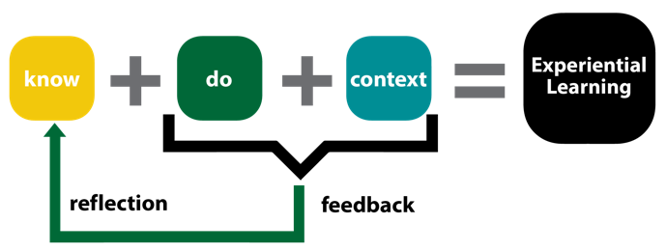
Field to Fjord : Planning for Experiential Learning in a rich context beyond tourism

A field course is a type of experiential learning that involves students in hands-on activities in a natural or cultural setting outside the classroom. Below are relevant practical teaching and learning considerations.

Course Title and Description
Provide a brief overview of the course, its objectives, and its expected outcomes.
Explain how the course aligns with the curriculum and the program-level learning goals.
Specify the prerequisites, co-requisites, or recommended courses for the field course.
Course Schedule and Location
Dates/Times/Duration
Location(s)
Indigenous Land Connections
(treaty, protocol, etc.)
Transportation Plan
Link to Map
Teaching Environment and Methods
Describe the teaching environment and the facilities available at the field course site(s).
Provide examples of the types of tasks or assignments that students will complete in the field course setting. How will you manage complex teaching needs such as different lab stations?
How will students consolidate learning after an intensive learning experience? In groups, partners, collectively?
Reciprocal Community Relationship – describe how students will help, or not hinder, the community and how the local community may contribute to the students’ learning.
Site Information and Accessibility
Provide information about the accessibility and services available at the field course site(s), such as access to food, medications, parking, restrooms, water, electricity, etc.
Indicate the costs or fees associated with the field course, such as transportation, accommodation, meals, entrance, etc.
Provide contact information for the field course instructor(s), coordinator(s), or leader(s).
Provide a short list of the resources or references that students can consult before, during, or after the field course, such as books, articles, websites, etc.
What are the pre-trip meetings and expectations?

Safety Considerations and Risk Management Related to Teaching
Identify the potential hazards or risks associated with the field course, such as weather, terrain, wildlife, equipment, etc. How will this impact learning?
Explain the measures that will be taken to prevent or minimize the risks in the field course which would impede learning, such as safety training, site assessments, etc.
Provide a list of the required or recommended personal protective equipment or clothing for the field course, such as helmets, gloves, boots, etc.
How will students be informed of their rights and responsibilities in the field course, such as local laws, informed consent, waivers, insurance, etc.?

Reflection Considerations
Provide a list of questions or prompts that will help students reflect on their learning experience in the field course.
How might you encourage students to think critically, creatively, and ethically about the field course topics and activities?
How might you ask students to relate their field course learning to their prior knowledge or experiences, personal interests, or future goals.
How might students document/share their reflections such as, journals, blogs, portfolios, presentations, or other collaboration tools.

Feedback and Assessment Considerations
Explain how students will receive feedback and be assessed on their performance and learning throughout the field course.
Specify the criteria and standards that will be used to evaluate students’ work.
This may be rubric, see ALDA, a teaching tool for help in creating this.
Indicate the weight or percentage of the field course in the overall course grade.
You may want to consider outcomes-based assessment for this practical type of learning.
Provide a rubric or a sample of the feedback or assessment form that will be used in the field course.

Please outline for each day how students will receive feedback, give you feedback, and reflect on their learning (as part of the EL cycle described above) relevant to the daily activities and location.

Date | Location | Activities | Student Reflection | Feedback to Instructor | Feedback to student

