

**Peer Review of Teaching Template (sequentially co-taught courses)**

**Context**

This template is intended to be used by faculty (or modified by departments/colleges) to conduct peer reviews of teaching that align with the Policy on Peer Review of Teaching Practices. Peer review encompasses design (goals, content, alignment), approaches to instruction and assessment, creation of the learning environment and reflection and iterative growth in these areas. As such, the peer review process involves more than an observation of a teaching session.

**Suggested Peer Review Process**

1. Reviewees (henceforth called educators) and reviewers are matched through standard college/department process.
2. The educator completes the pre-review information (pages 1 and 2 of the template) and provides it to the peer reviewer.
3. After reading the completed pre-review information, the peer reviewer and the educator meet to discuss the course, the educator’s approach, timelines, and what materials will be generated/considered in the review (e.g., observation, Canvas site, syllabus, exams of assessment and feedback). Student materials should be anonymized or shared with permission.
4. Meet with educator’s co-instructors to gather information about the educator’s collaboration with their colleagues.
5. The reviewer should take a moment to reflect on their experiences and worldviews, to consider how this may influence their perspective for this review. This will help the reviewer write an equity statement later.
6. The reviewer uses the peer review template to work through the agreed process/materials, reviewing the plans and actions of the educator in each category, noting the educator’s strengths and areas for improvement in the space provided. The template is shared with the educator who completes the final section with reflections and plans for enhancement.
7. The peer reviewer meets with the educator to discuss the review, after which the completed peer review template is provided to the educator and dean or department head as per college/department process.

**Educator: please complete the questions below and on the next page and send to the reviewer. Provide access to your Canvas course site if applicable.**

**Educator and Peer Reviewer**

1. Educator’s name:
2. Peer Reviewer’s name:
3. Date of review (month/year)

**Course information**

1. Course name and number (e.g., EARTH 101):
2. Course title (e.g., Introduction to the Planet Earth):
3. Relationship of course to certificate or degree programs

(e.g., required or elective for B.Sc. in Earth Awareness):

**Canvas course** (if applicable)

1. URL for the **course home page**
2. URL for the **course syllabus**

**Gathering Peer Review Evidence**

Peer Review is a process that focuses on 4 key areas:

* Goals, content, and alignment
* Instruction (2a)
* Assessment (2b)
* Learning Environment

Educators and reviewers should select from a variety of sources of evidence in order gain helpful, fulsome, and accurate information for the peer-review process. Observation is an essential, but not sufficient, source of peer review evidence to support each area. The following types of evidence may also be helpful in developing a comprehensive picture of teaching practice:

1. URL for the **calendar of assignment due dates**
2. URL for **assignments**
3. URL for **quizzes and examinations** (if applicable)
4. URL for **discussions among students and educator(s)** (if applicable)

**Relevant Educator and Course Context**

1. 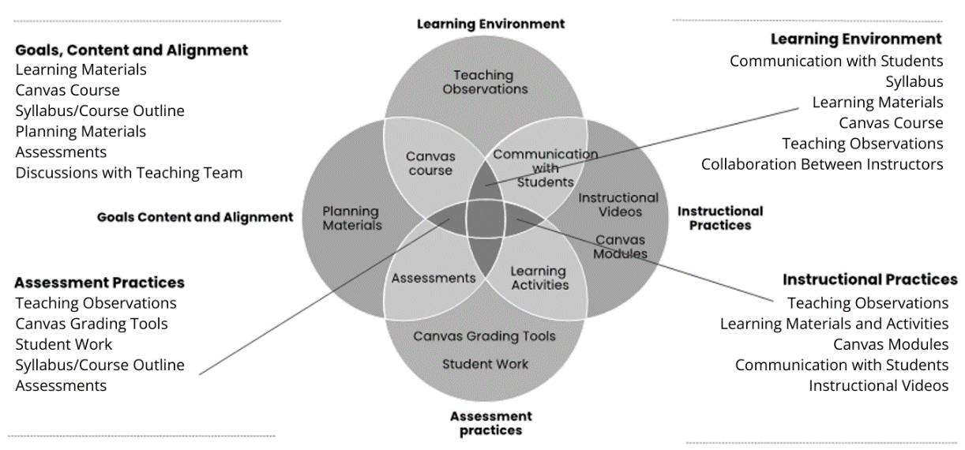Please outline details about your teaching approach and/or the course that may be relevant to the reviewer (e.g., changes made in response to previous feedback, specific rationale for the approach you have taken in design, instruction or assessment, notes on collaboration with co-instructors, relevant points about the students in the class, specific aspects of the course, like class size, that may constrain instructional approaches)

1. Please comment on your role in this co-taught course:
2. Please comment on your involvement in the planning and development of learning materials for this co-taught course:
3. Are there any elements of your identity (that you feel comfortable disclosing) or the course content that you believe may influence the review, and which you’d like the reviewer to consider explicitly?

1. Please outline areas on which you would welcome feedback (e.g., a new instructional approach, an area you revised based on previous feedback, your approach given your teaching philosophy):

**Co-Teaching Considerations**

Sequentially co-taught courses work best for students when educators collaborate to make a smooth, consistent, and coherent single learning experience for them. Educators should design their portion such that it is consistent with other modules, and such that it builds towards the overall course outcome learning outcomes, in a manner agreed upon by the entire teaching team.

Reviewers are recommended to have conversation with both the educator and other teaching team members to discuss the educator’s role in the course and collaboration with colleagues. **Note that some sections of the template may be left blank if the educator does not have a significant role in that area.**

1. Please include additional information you wish to have the reviewer consider:



**Peer Review Template for Sequentially Co-Taught Courses**

|  |  |  |
| --- | --- | --- |
| **Criterion 1: Goals, content, and alignment**  *How the course is structured and organized to achieve clarity, accessibility and alignment of outcomes, learning activities, and assessment.* | | |
| * **Appropriate and clear learning goals (outcomes)** * **Learning goals (outcomes) are aligned with program, curricular and/or institutional expectations** * **Content is appropriate and aligned with learning goals (outcomes)**   **You might see:**   * [Course learning outcomes](https://teaching.usask.ca/remote-teaching/learning-outcomes.php) are appropriate for level of study and nature of course (e.g., lab, seminar, lecture, experiential) in the portion for which the educator is responsible * Course learning outcomes clearly defined, building on or preparing students for outcomes in other courses, and aligning with program learning outcomes * Educator’s portion of the course designed in a way that presents and communicates content clearly * [Accessibility issues addressed](https://open.ubc.ca/access/toolkits-access/oer-accessibility-toolkit/) throughout the course * Co-teaching is well planned, such that the course feels coherent to students | | **Feedback for the Educator**  **Evidence Found:**    **Strengths:**    **Areas for Improvement:** |
| **Where to look** | **What you could comment on** |
| * Course syllabus * Teaching observation: directions given * Assessment information or directions * Conversations with co-instructors | * Easy for students to understand how the course is organized overall and how the educators portion contributes to the clarity and coherence * Clear what students need to know or be able to do at the end of the course (outcomes) and how the outcomes are checked by assessment * Expectations for individual assessments in the educators' section of the course are clear and available to students in advance. * Expectations for common assessments are consistent with other educators in the course. |
| * Modules in Canvas * Learning materials * Session plans or other planning material * Conversations with co-instructors | * Pages and modules use consistent, effective structure to present content and offer learning activities that flows well from other educators work. * Breadth and depth of content/intended learning is achievable given course duration and level, and factors in content led by the co-instructors * Goals for selecting specific types and examples of content are clear, and aligned to learning outcomes for students |

|  |  |  |
| --- | --- | --- |
| **Criterion 2a: Instructional practices**  *How the educator fosters an inclusive learning environment, provides varied and current resources, and supports students learning.* | | |
| * **Instructional practices are planned and organized** * **Instructional practices are aligned with learning goals (outcomes)** * **Instructional practices engage students in the learning process** * **Instructional practices facilitate achievement of learning outcomes** * **Instructional practices integrate research, scholarship, artistic work, and/or professional activities**   **You might see:**   * Appropriate tools (e.g., technological) are selected and used to facilitate communication and learning; educator strives for consistency with co-instructors in this area * The type of instruction is likely to result is students demonstrating the outcomes * Frequent and timely student-educator contact is integral to the course, and makes effective use of having multiple instructors * A variety of course-specific resources are provided (e.g., videos, text) that support student understanding and engagement with materials * Adequate opportunities for interaction, collaboration, communication, and support between students as well as between students and educator are provided | | **Feedback for the Educator**  **Evidence Found:**    **Strengths:**    **Areas for Improvement:** |
| **Where to look** | **What you could comment on** |
| * Learning materials * Teaching observation: responses to students * Educator videos * Communication sent to students | * Well-paced course activities that tied to outcomes and distributed across modules/weeks; instructor attempts to fit a reasonable amount of content into the portion of the course allocated to them, given the level and type of course * Student questions encouraged and educator responses deepen learning * Examples, resources and activities that reflect scholarship used in ways that students can understand and find relevant to their prior learning/experience and other learning they have done in the current course |
| * Course syllabus * Teaching observation: student learning activities * Directions to students * Discussion forums | * Examples of times when students (1) think, talk, or write about their learning, (2) reflect, relate, organize, apply, synthesize, or evaluate information, and/or (3) perform research, virtual lab or studio work, or hands on activities * Questions and student responses deepen disciplinary understanding and application of main course content * Content and outcomes are directly linked for students, both for the educator’s section-specific outcomes and the overall course outcomes. |
| * Course syllabus * Discussion forums * Teaching observation: student learning activities | * Student interest and engagement with the course materials and with each other through, for example, discussion, collaborations, presentations, etc. * Class discussions facilitated by the educator through encouraging, probing, questioning, summarizing, etc. |

|  |  |  |
| --- | --- | --- |
| **Criterion 2b: Assessment practices** *(if applicable)*  *How the educator helps students develop the intended learning outcomes for the course and checks to see if students have achieved them.* | | |
| * **Assessment practices facilitate achievement of learning outcomes** * **Assessments of student learning are relevant, aligned with learning goals (outcomes), transparent, and fair** * **Feedback to students is prompt and constructive, and at regular intervals throughout the course**   **You might see:**   * A series of formative assessments (practice, no marks) or a staged/laddered (doing a series of parts over time) summative one * Clearly stated assessment requirements, criteria, rubrics, and/or samples * Constructive and timely feedback * Assessment of outcomes for the educator’s portion of the course are designed to help students build towards achieving overall course outcomes * Students doing varied tasks to check their knowledge, attitudes, and skills (e.g., videos, self-assessment, essays, quizzes, blogs, podcasts, etc.) * Use of self and peer feedback or assessment | | **Feedback for the Educator**  **Evidence Found:**    **Strengths:**    **Areas for Improvement:** |
| **Where to look** | **What you could comment on** |
| * Course syllabus * Assignment directions with assessment criteria * Pages/Modules in the course | * Assignment grading criteria are clearly communicated * Examples of previous student work of varying quality are provided, along with a discussion of the differences between them * The course outcomes assessed by specific assignments or tests are overtly stated in the assignment description or syllabus; they extend beyond module-specific outcomes, relating directly to overall course outcomes |
| * Student Assignments provided by educator * Discussion boards * Feedback samples * Conversations with co-instructors | * Impact of educator feedback on drafts of assignments * Timeliness of feedback * Effectiveness of feedback (clear, positive, specific, and focused on observable behavior that can be changed) * Feedback communicates to students where to focus their learning effort * Communication between instructors about student progress to better meet student learning needs (or other defined process between instructors) |

|  |  |  |
| --- | --- | --- |
| **Criterion 3: Learning Environment**  *How the educator makes learning/content relevant to students and engages students in thinking and doing independently and together.* | | |
| * **Learning environment is respectful and inclusive** * **Learning environment allows for the recognition of, and engagement with, diverse perspectives/worldviews** * **Learning environment fosters student interest, motivation, engagement, participation** * **Educator/Teacher is accessible and responsive to students**   **You might see:**   * Frequent and timely student-educator contact is integral to the course, enhanced by co-teaching approach * The educator make an effort to build rapport with students, even if their section of the course is not as long in duration * A diversity of course-specific resources provided (e.g., videos, text) that support student understanding and engagement with materials * Students are actively encouraged to share learnings and resources * Educator leverages their expertise (and those of their colleagues) to expose students to multiple approaches or perspectives | | **Feedback for the Educator**  **Evidence Found:**    **Strengths:**    **Areas for Improvement:** |
| **Where to look** | **What you could comment on** |
| * Teaching observation: student learning activities * Teaching observation: student & educator interactions * Discussion forums * Communication sent to students * Course syllabus | * Learning activities include students sharing resources they have created that reflect their learning * Clear norms and positive interactions are visible * The educator encourages and fosters a healthy exchange of ideas among course participants, who are visibly engaged * The learning materials present diverse voices, perspectives, and worldviews and use inclusive language * The educator is responding to student concerns, interests and needs for accommodation and directs them to others as needed * Positive collaboration between the educator and co-instructors, modeling healthy academic dialogue |
| * Course syllabus * Modules in the course * Learning resources | * Learning materials clearly communicate current key concepts/ideas, are concise and connect to students’ prior experiences and/or context * Student engagement with diverse perspectives, including Indigenous ones * The educator encourages students to contact them, with guidance on when they are the most appropriate person to contact |

|  |  |
| --- | --- |
| **Summary and final reflections**  *Linked to criterion 4, reflection and iterative growth* | |
| **Reviewer:**  Overall reflections emerging from the review process and response, where appropriate, to feedback (e.g., from previous peer review, from students):    Examples of good practice you would like to commend/share:    Please note any factors related to equity which might influence your review and how you considered them in the process and provision of feedback. Also, how did you incorporate consideration of the educator’s equity request into this review (see pg. 2, #16)?  *To be used by educator to inform reflections and by any others interpreting the feedback.* | **Educator:**  Reflection on the feedback, and plans for future enhancement: |