Course Number [#]: [Course Title]

Learning Module [#]: [Module Title]
Developed by
[Please insert author name, and author’s affiliation]

Introduction

Learning Objectives
When you have finished this module, you should be able to do the following:

Module Instructions

Required Readings

Key Terms and Concepts

Learning Material
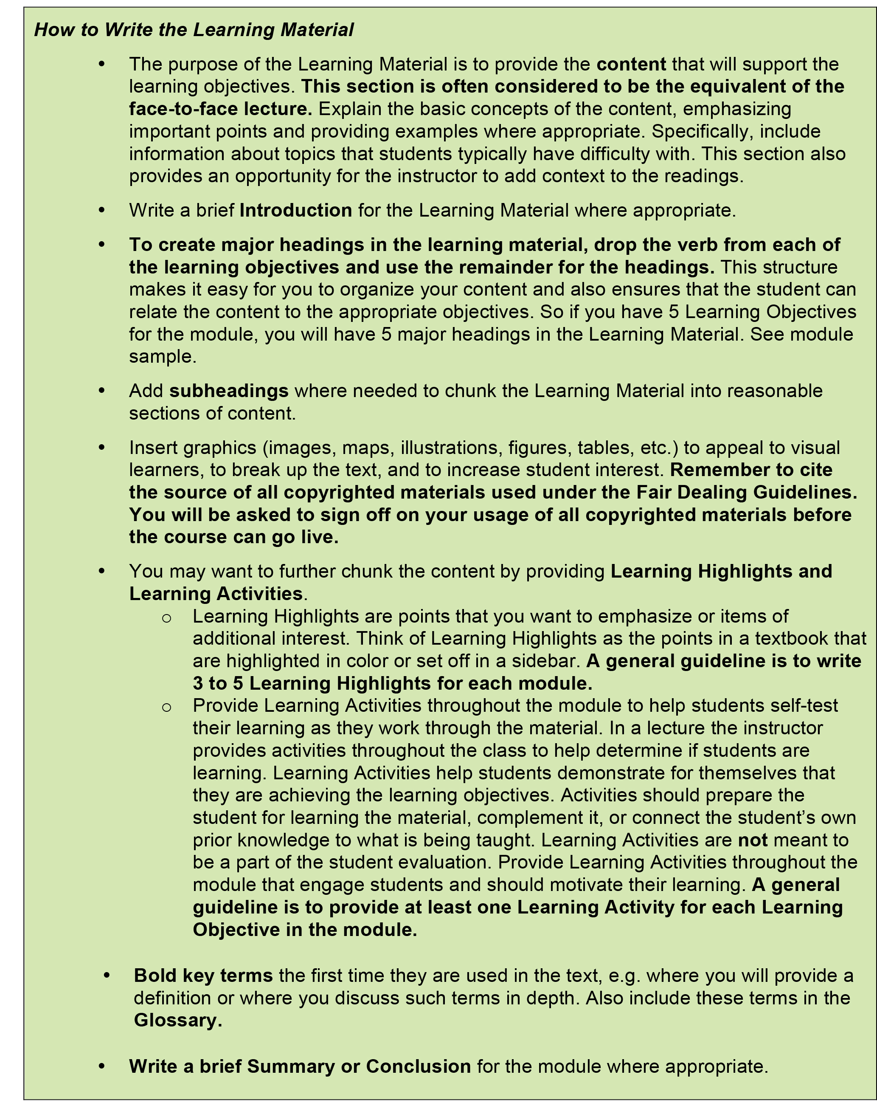

Introduction

Major Headings
[Add major headings to match each learning objective.]

Conclusion

Discussion Questions
1.
2.
3.

Review Questions and Answers/Self-Test and Answers
1.
Answer
2.
Answer
3.
Answer
4.
Answer
5.
Answer
Glossary

References

Supplementary Resources
1.
2.
3.

